Advance Industry Maintenance
Tapan Rathod¹, Prof. Ajaykumar T. Shah²

^{1, 2} Dept of Computer Engineering

^{1, 2} Alpha College of Engineering and Technology

Abstract - All the work in company is on Paper which is very time consuming and very difficult process, Every IT and government Professionals have to submit the report of their particular day to day work to the project manager after project manager assigns or starts new tasks for the projects. So we need an electronic system enable the rapid creation and distribution of documents. Therefore, Advance Industry Maintenance replace paper documents with electronic documents. In industrial area electronic documents as information sources have increased in number and retrieving the information among huge number of documents become a problem. A recent study shows positive feedback from employees towards establishing a document management system in their work place new innovative tools are necessary to access relevant information, therefore employees are very interested to have a system to manage, industry needs a well-organized repository in order to reuse information throughout the research, is creating new opportunities for collaboration, coordination, and information exchange among employees that work on a construction project. And consequently reduce costs and response times. The entire service is delivered through INTERNET browse so people can access documents anytime.

Keywords – Document Maintenance, Online Documents, Preserving, Confidential Documents, Role Hierarchy, Digital Assets Maintenance.

I. INTRODUCTION

The proposed system is a web application which provides the user an ability to register to this application and manage their accounts. Each employee will have an account with their own home page.

Employees can hide/lock their confidential documents from lower scaled employees from them.

Admin user shell be able to define different document types such as process document, invoice document, order document etc.

Admin will also be defined the search tags that are available for that particular type i.e. using which parameter (e.g. customer name, date, amount, year, etc.) can document of particular type be searched.

Admin:
- In User Management:
Admin Shell be able to create and maintain users’ information. (i.e. user name, department, contact details, user category).

- Rights Management:
Admin shell be able to define user categories and matching user rights (Upload, Edit, Remove, View) that users of that category should have for different types document (Process document, Invoice Document, etc.).

- Department Management:
Admin shell be able to create and maintain list of Department.

- Document Verification:
Admin shell be able to verify uploaded document and details. This is to ensure that search tags entered by original user are correct. Admin can reject document if such details found wrong. Document will not be part of any report/ Search till they are verified and approved.

User:
- In Document Category Management:
User shell be able to define different document types such as process document, invoice document, order document etc.
[Admin will also be defined the search tags that are available for that particular type i.e. using which parameter (e.g. customer name, date, amount, year, etc.) can document of particular type be searched.]

- Document Management and Tag Handling:
User shell be able to upload (PDF format) document of particular types, as allowed for users’ category. User shell be prompted to enter data for applicable search tags depending on type of document being uploaded. User shell be able to alter tags till it is verified by verifying user or if has been rejected. User will not be able to update search tags once document has been verified and approved.

- Document Searching and Tag Alert:
User shell be able to search document on bases of tags assigned to document as long as user has rights to do so.

- Retrieve Document:
User shell be able to view, download, print, email, document as long as has rights to do so.

User Management:

- Includes functionalities for registration, login, change password, recover password, update profile etc.

ΙΙ. LITERATURE REVIEW
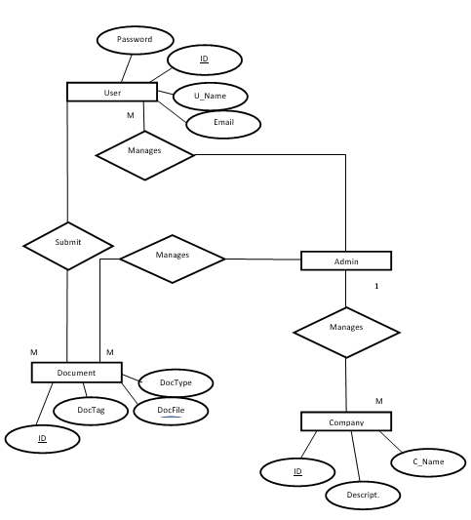

The purpose of this document is to provide a detailed overview of our website is to make the management of corporate information easier through simplifying storage, security, version control, process routing, and retention. The benefits to an organization include improved efficiency, better control, and reduced cost.

III. WRITE DOWN YOUR STUDIES AND FINDING

In brief, this system aims to make the management and maintenance of digital assets and corporate information easier through simplifying storage, security, confidentiality, version control, process routing, role hierarchy and retention. The benefits to an organization include improved efficiency, better control, and reduced costs.

Automation to be required for project “Advance Industry Maintenance” therefore I am going to develop my newly assigned project in “Advance Industry Maintenance”, where the following modules are covered as below:

- Document Type Management.

- User Category and Right Management.

- Department Management.

- User Management.

- Upload Document and Enter / Alter tags.

- Verification of Document.

- Document Search.

- Retrieve Documents.

- Report.

IV. CONCLUSION

We can conclude that we have developed the system with features of Advance Industry Maintenance are Document Management, Document & Files Verification, Total Verification of uploaded content by admin for full security of valid document and files that someone cannot steal. Different types of Companies/Departments/Racks/Columns/Files/Documents management by admin.

V. ACKNOWLEDGMENT

We express our sincere thanks to Prof. Ajaykumar T Shah of Computer Engineering department, ALPHA
COLLEGE OF ENGINEERING AND TECHNOLOGY for his support and guidance for doing the project and care taken by him in helping us to complete the project work successfully. This is to place on record our appreciation and deep gratitude to the persons without whose support this project would never been seen the light of the day. We express my sincere thanks to Prof. Ajaykumar T Shah Head of the Department, in Computer Engineering, ACET for extending his help.

We have immense pleasure in expressing thanks and deep sense of gratitude to All Faculties of Computer Engineering, ACET for their valuable suggestion and guidance throughout this project.

This is to place on record our appreciation and deep gratitude to the persons without whose support this project would never been seen the light of the day.

We express our sincere thanks to faculties, Head of The Department, at Computer Engineering, ACET for extending their help.

Finally, at the outset we would like to thank all those who have directly or indirectly helped us to accomplish our project successfully.

VI. REFERENCES

- Roger s. pressman, ‘Software Engineering, A Practitioner’s Approach’, Fifth Edition.

- Michael R Blaha and James R Rumbaugh, ‘Object Oriented Modeling and Design with UML ‘, Second Edition.

- www.w3schools.com

- www.alfresco.com

- YouTube Tutorials

- Tutorials points

